Realistic Disaster Scenario
(RDS)
Introduction
AXAXL, being a re-insurance company provides re-insurance to multiple insurance companies (Cedants) like AMLIN - MAIN PROG, ARCH PI/D&O/GL etc., under specific re-insurance programs. These reinsurance programs are grouped under different OBUs – Operational Business Units based on the region and specific business (casualty, marine, airlines etc.,) Eg. XL RE EUROPE SE - UK - CASUALTY
In turn, these insurance companies provide insurance coverage to many individual companies of different sectors. For example, under a program AMLIN - MAIN PROG re-insurance is provided for the insurance company AMLIN and AMLIN in-turn cover ‘AXUS’,’2XL’ etc., under various insurance policies.
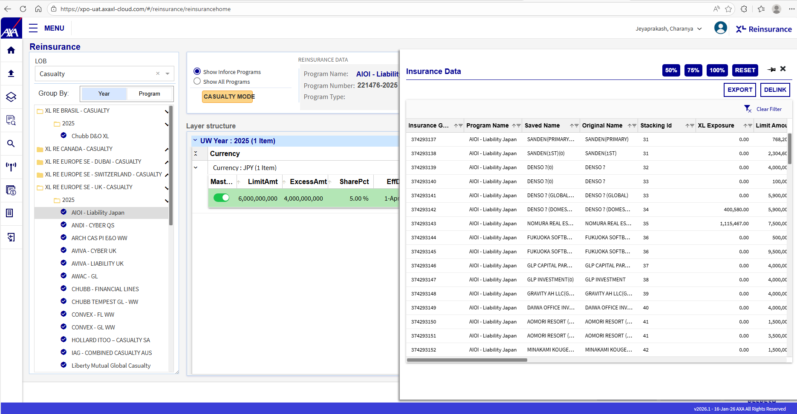
When a loss is encountered by the insurance company(AMLIN - MAIN PROG) due to high value claims made by the end policy owners (‘AXUS’,’2XL’ etc.,),in case of a disaster, the loss will be upon XL as well.
In case the loss is disastrous say when multiple companies which have huge loss exposure suffer loss during same time period, the loss amount may be a disastrous sum to be borne as well, which requires a lot of preparation from the end of XL as a re-insurer.
In order to be prepared for such worst-case situations, EMT being the Exposure Monitoring Tool provides a module called RDS which helps in simulating such scenarios well ahead through various parameters It analyses and provides report on how much amount AXAXL would need in order to pay the claim as a re-insurer as per the policies of the re-insurance contract/treaty.
The analysis and report rendered consequently involve various parameters of the re-insurance contract like the limit_amount, excess_amount, ROL (Rate Of Loss), NORs (Number Of Reinstatements) etc., which play a crucial role in determining the Cap loss that XL needs to provide to the insurance companies during such a scenario.

LossUSD Calculation
For lossUSD calculation
- Open XPO application

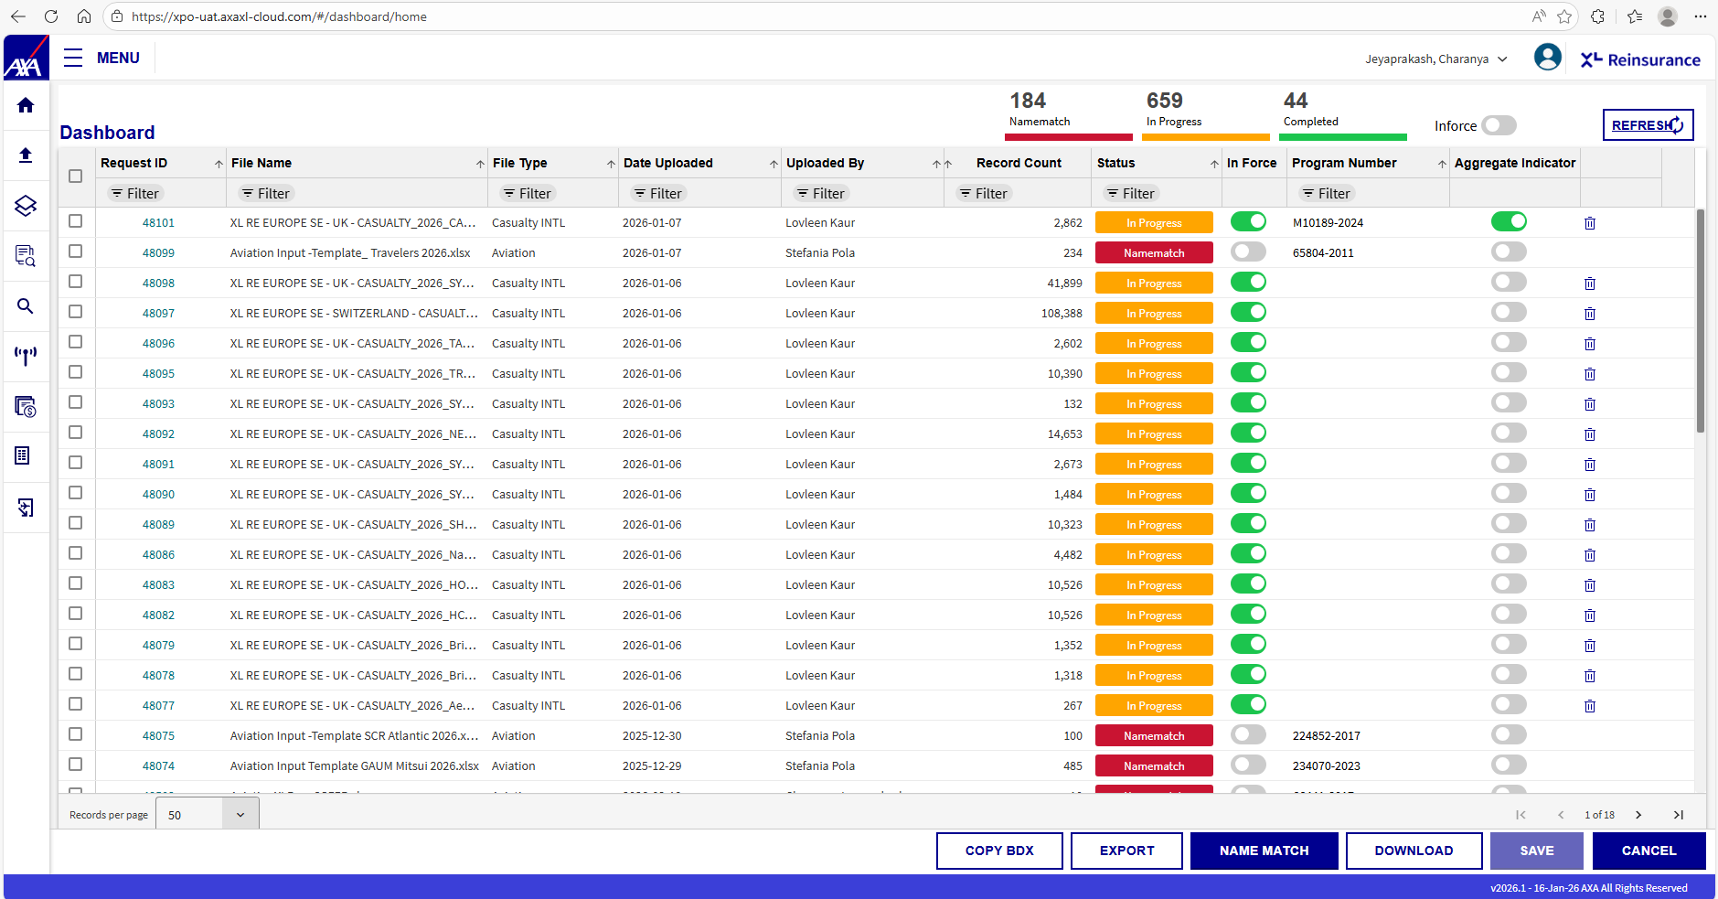

- Select an uploaded BDX (Insurance) file which is yet to be linked to a program. In the corresponding ‘Program Number’ field of the row double click and paste the reinsurance program number to which the BDX must be linked to. Then press tab and click on ‘Save’
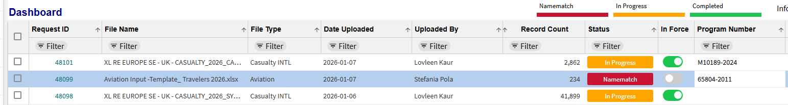

- This will trigger the XL Exposure/LossUSD calculation based on the insurance data in BDX file and reinsurance data of the program linked.

- Say if only ‘CGL/GL’ lob is present in both Insurance and Reinsurance data of the selected programs, though multiple LOBs are selected in the screen, loss calculation occurs only for the LOB ‘CGL/GL’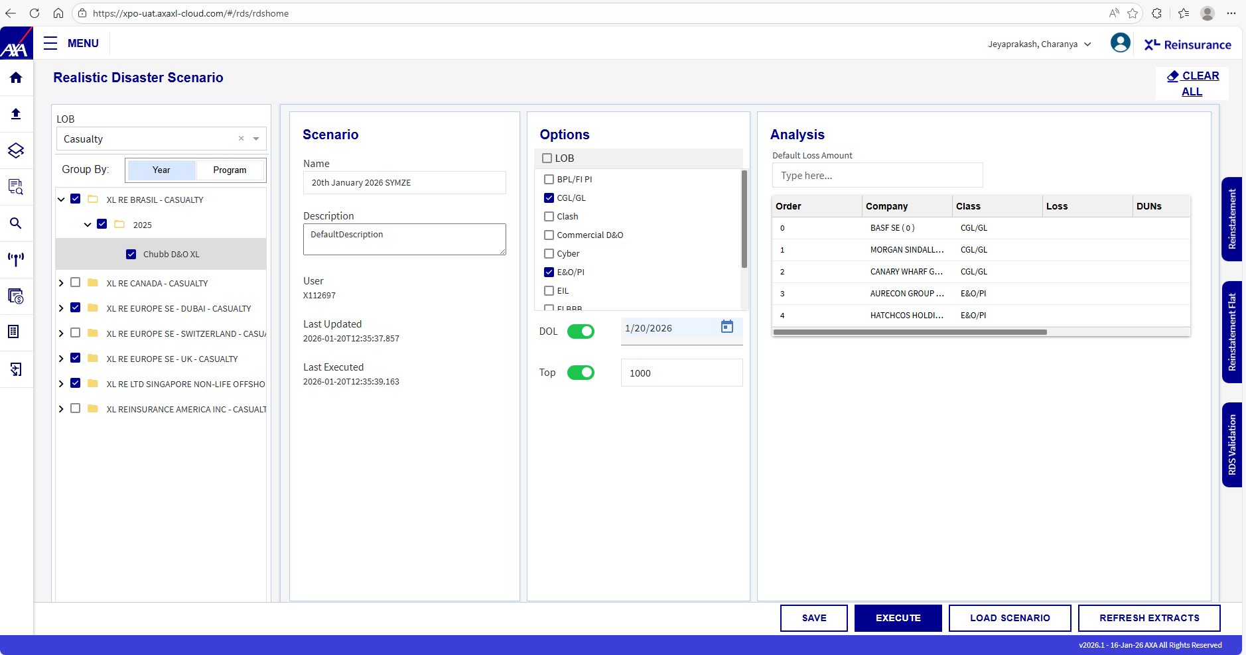

- During the loss calculation process, the stored procedure ‘process_results_program’ is called which in turn calls the SP process_results
- Process_results_program SP checks on the ‘OBU’ passed and invokes the respective calculations. Internally it invokes the SP process_results(for Latin America it calls process_results_LA) with the following parameters
  - Program_number (Re-insurance program ID)
  - Class
  - Loss scenario group GUID
Note: The SP process_results is called for each of the classes associated with the re-insurance program.
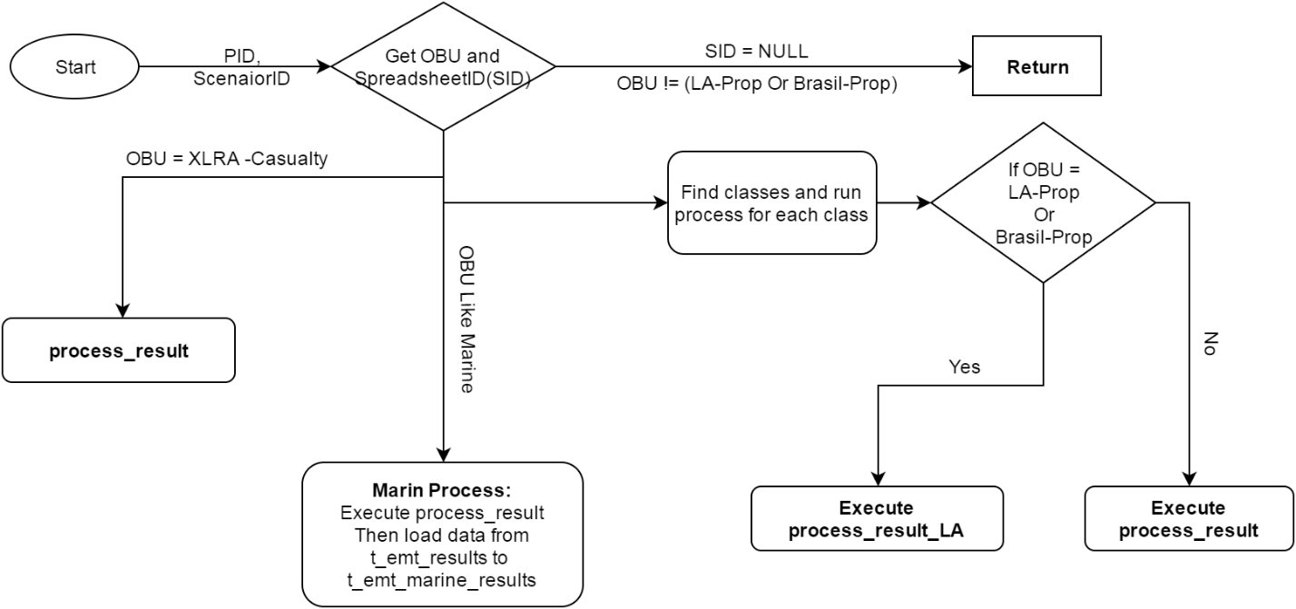

- Original loss calculated happens in the SP ‘process_results’. For the example considered Program number will be the re-insurance program ID of ‘ACE TEMPEST - GL’ – 279372890, Class is CG/GL as discussed above and Loss scenario group GUID is null here as we have not created any ‘Loss Scenario’ (Will be dealt in the later part of the document)
SP logic - Process_results
- The SP ‘process_results_extract’ is a replica of ‘process_results’ with the intermediate results inserted into ‘global temp tables’ for analysis
- Execute this SP with the sample parameters (ACE TEMPEST-GL) and let’s see the intermediate calculations that lead to ‘Loss scenario calculation’
- In the first step, re-insurance data associated with the class passed ‘CGL/GL’ for the ACE TEMPEST – Gl program is pulled into #t1 table
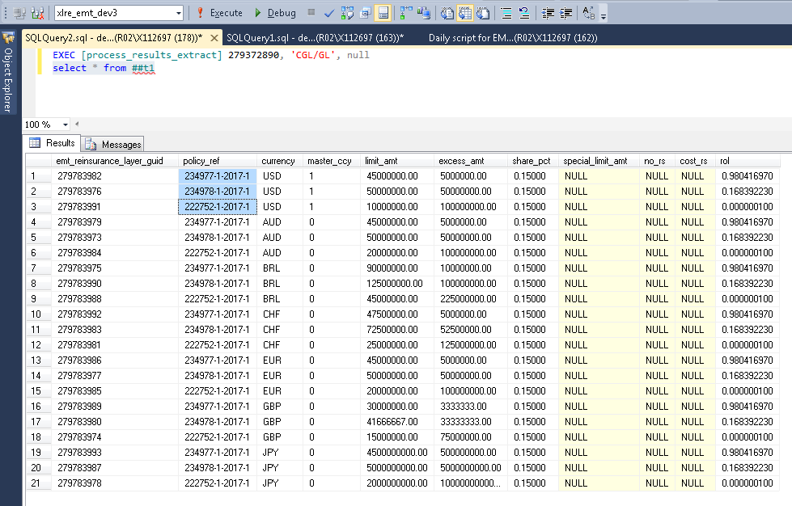

There are totally 3 layers for each currency in this re-insurance program and all have the class ‘CGL/GL’ associated with them. So the entire 21 rows (7 currencies * 3 layers) are pulled.
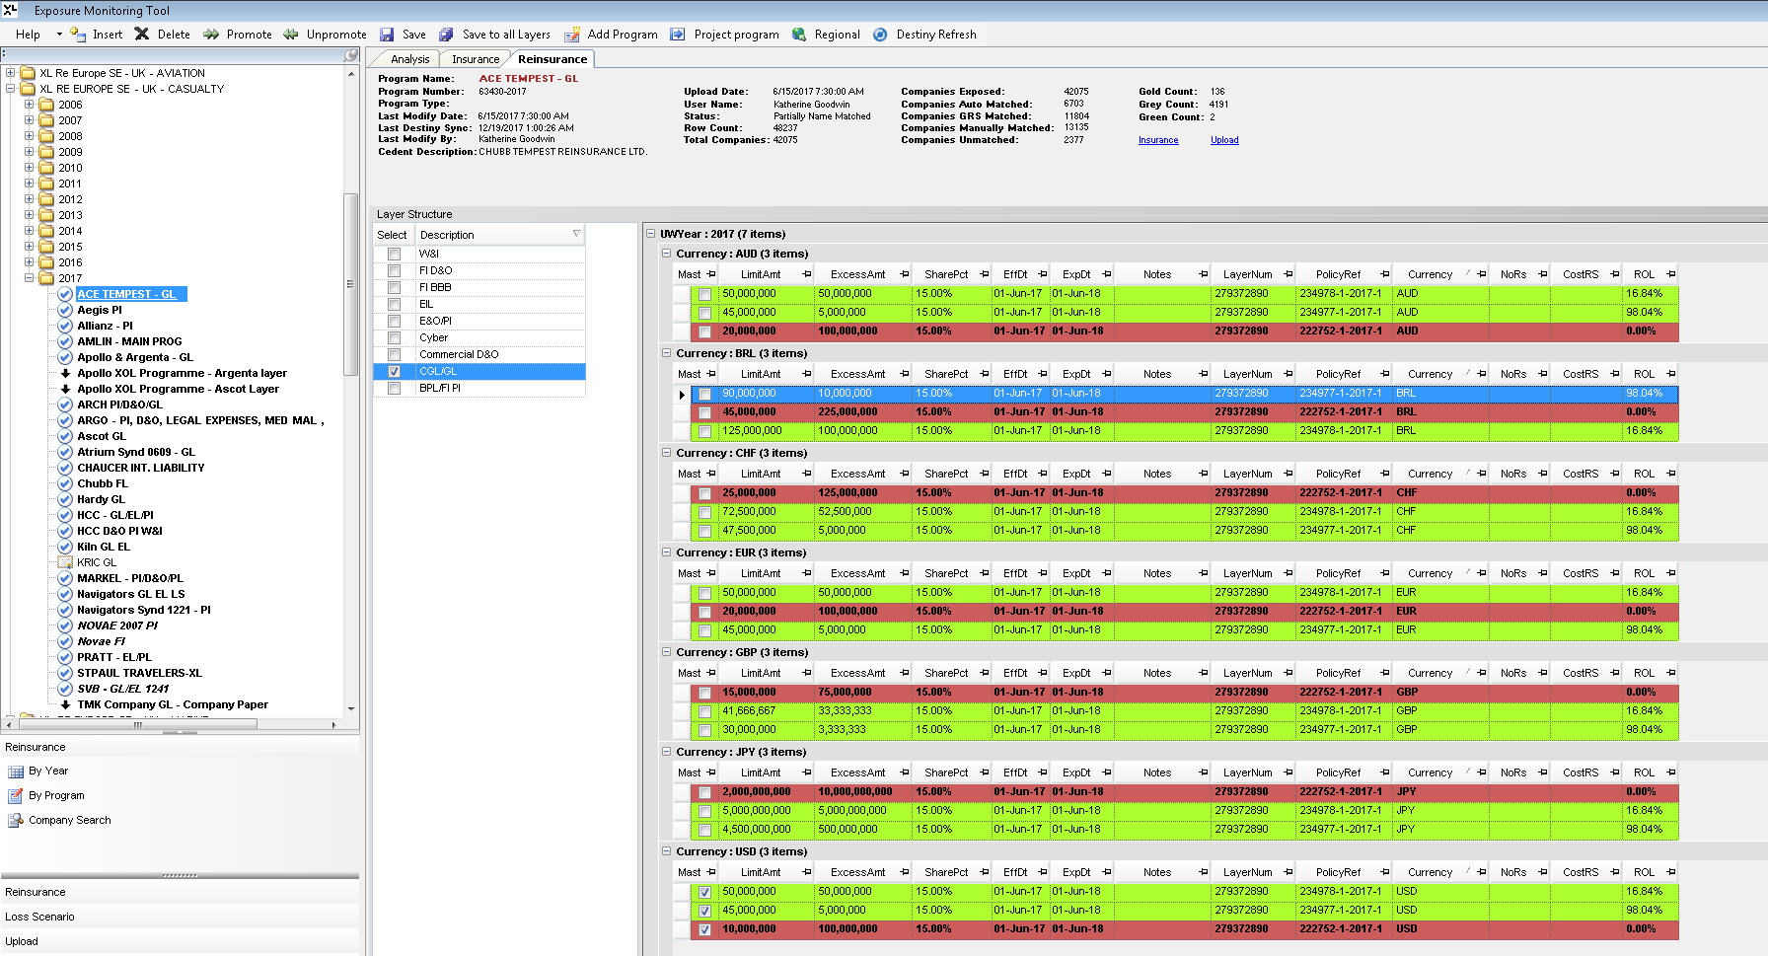

- Then all the ‘insurance’ company details are pulled into #tin table. Of the 48237 records 41044 which are the distinct insurance companies associated with CGL/GL class are pulled

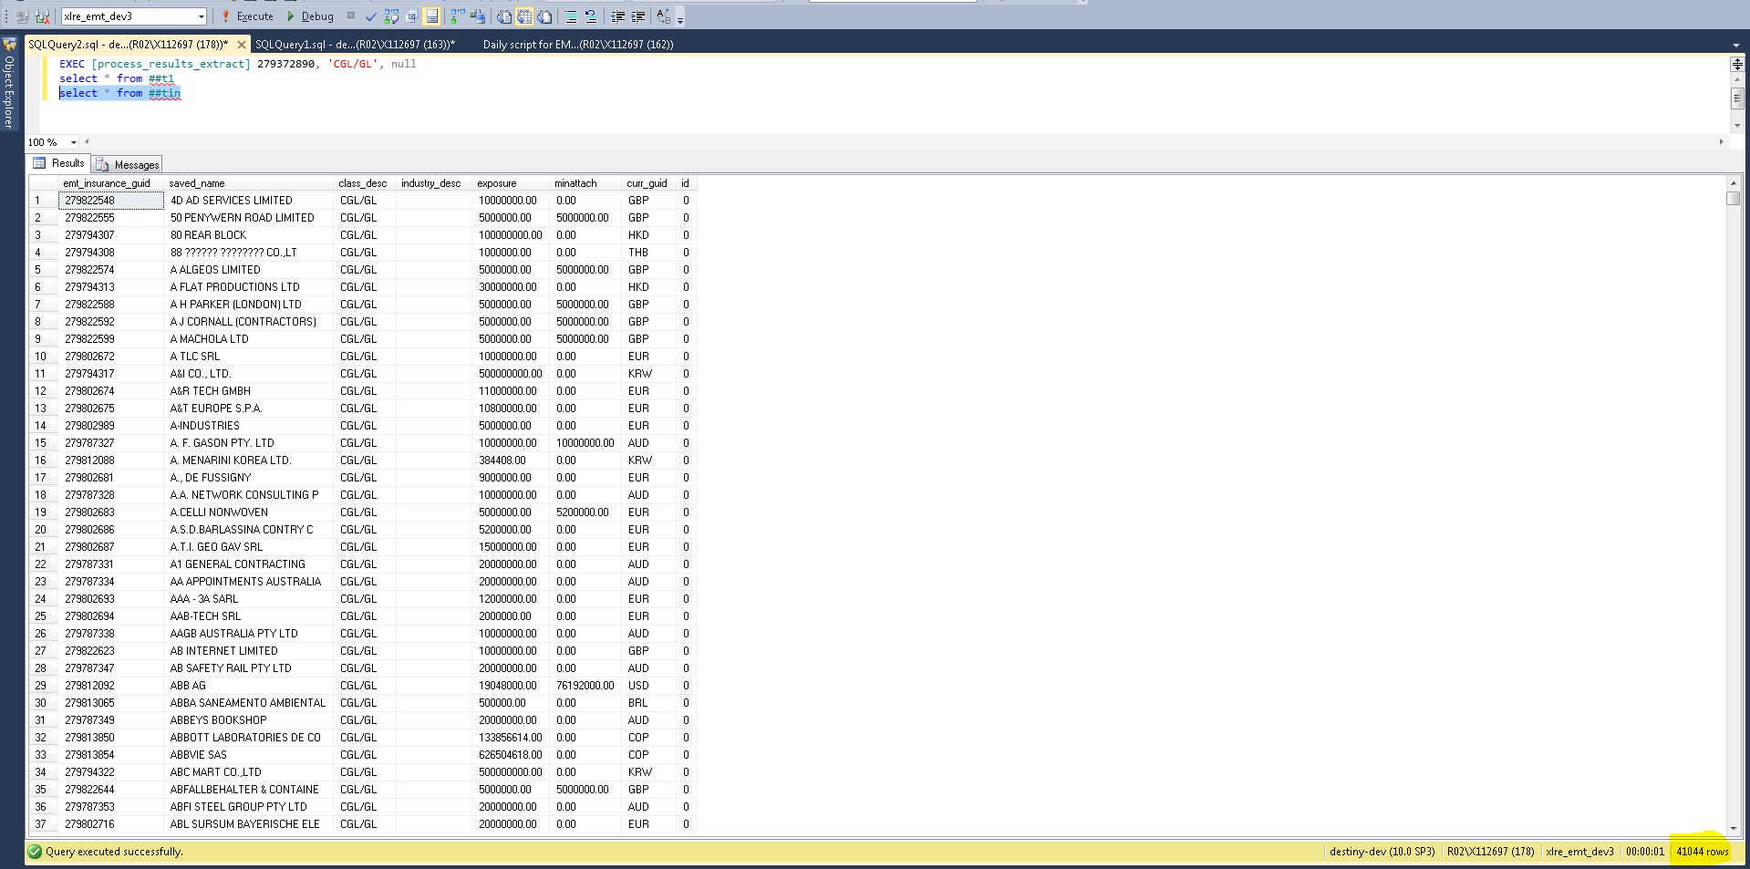

- The number of insurance company is cross multiplied with the number of layer information (#t1 CROSS JOIN #tin) = 21 * 41044 = 861924 in #t2. Here each insurance company is joined with every reinsurance layer available for that program
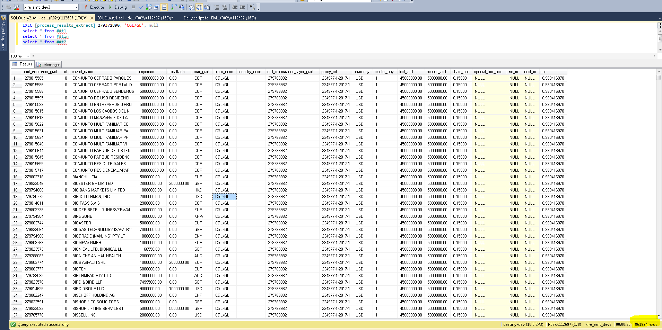
- For example the company ‘BIOTEM’ is joined with all 21 layer entries (3 policy * 7 currencies)
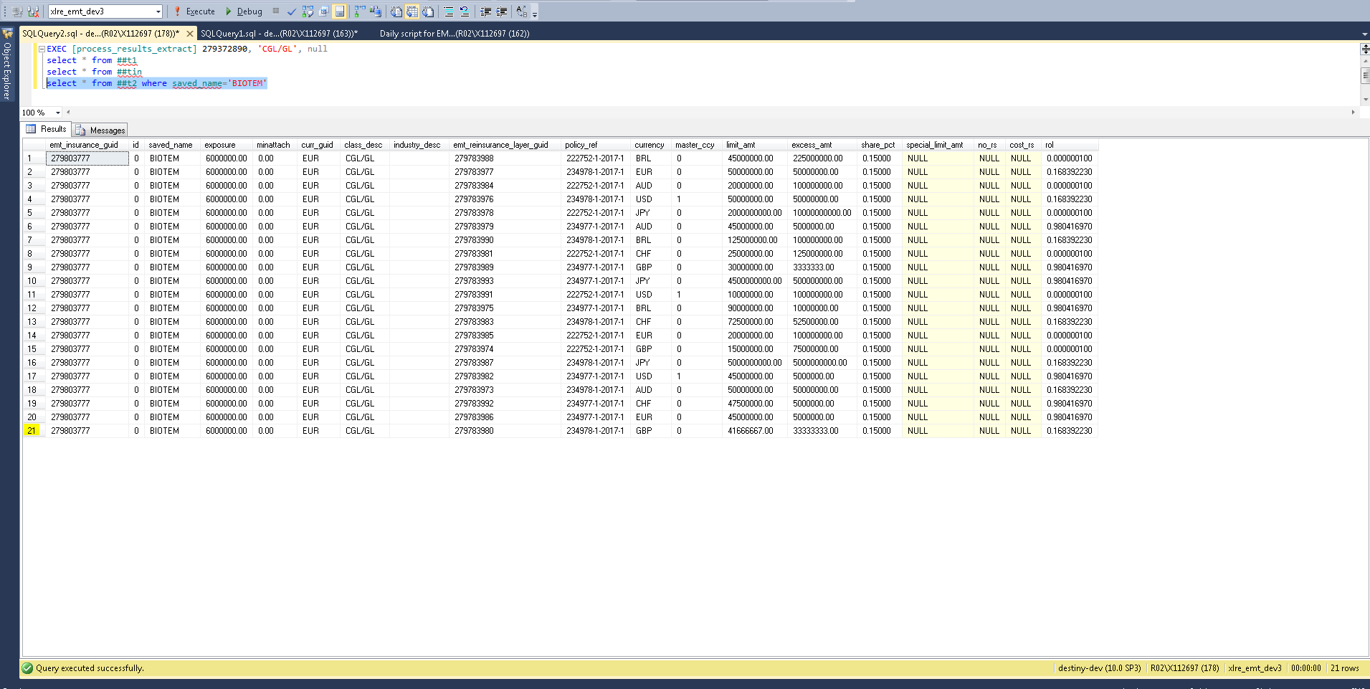
- This data is moved to #t3 with 2 additional columns added to it – ‘usethis’ and ‘losstolayerCCY’.
Though each insurance company is joined with all the currencies of a policy, only the entries for which insurance currency match the layer currency, ‘usethis’ column is updated to ‘1’ and that entry will only be considered further. Also ‘losstolayerCCY’ is calculated using the below formula for this entry
select *,usethis=case when currency=curr_guid collate database_default then 1 else 0 end,
losstolayerCCY=case when currency=curr_guid collate database_default then
dbo.mini( limit_amt ,dbo.maxi(exposure-excess_amt,0))*share_pct else null end into ##t3 from ##t2
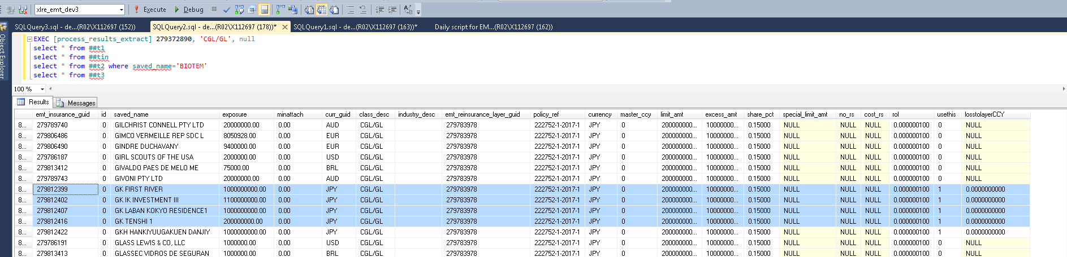
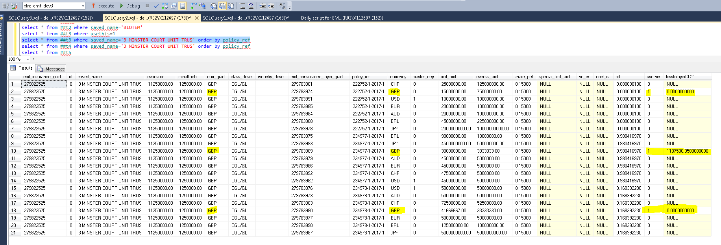
- When there is no match between the insurance currency and any of the layer currencies for a company then the master currency entry is considered for that company and ‘usethis’ columns is marked as ‘1’ but ‘losstolayerCCY’ is not calculated in #t3
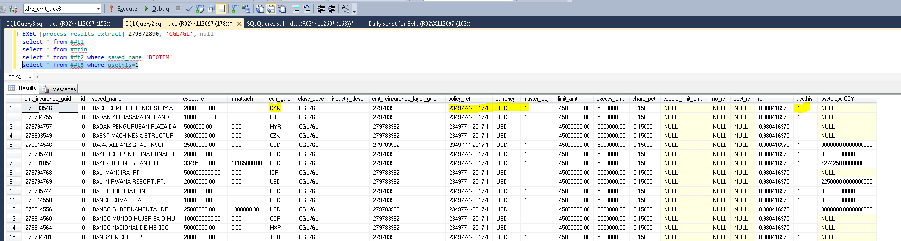

- All the records are now moved from #t3 to #t4. For the records where ‘losstolayerCCY’ is NULL, first the exchange rate for ‘Mastercurrency’ (based on the program layer information) with respect to the company currency is retrieved and then ‘losstolayerMasterCCY’ is calculated as below. These 2 columns are included in #t4 besides the #t3 columns as ‘rt’ and ‘losstolayerMasterCCY’
select ##t3.*,rt=rate,losstolayerMasterCCY=case when losstolayerCCY IS null then
dbo.mini( limit_amt ,dbo.maxi(exposure*rate-excess_amt,0))*share_pct
else null end
into ##t4
from ##t3
inner join @Xrate on ccy=curr_guid collate database_default order by saved_name

@Xrate is populated as below. This table variable basically contains the latest exchange rate details of all the currencies in insurance data with respect to its ‘Master currency’ for the re-insurance programs selected
INSERT INTO @Xrate
SELECT DISTINCT coalesce(curr_guid,'USD')curr_guid, MAX(effective_dt) AS effective_dt,
dbo.fn_getXRate(coalesce(curr_guid,'USD'), @master_ccy, MAX(effective_dt)) AS rate
FROM t_emt_insurance i
INNER JOIN t_destiny_xrates x ON x.CCY=coalesce(curr_guid,'USD') COLLATE database_default
WHERE emt_reinsurance_program_guid=@program_number
GROUP BY coalesce(curr_guid,'USD')

The function fn_getXRate retrieves the latest exchange rate for a from-to currency combination.
For example,
For any from_currency, if the to_curr is USD the latest exchange rate matching the from_currency is returned from t_destiny_xrates
For any from_currency, if the to_curr <> USD then then the latest exchange rate corresponding to the from_currency is divided by the latest exchange rate of the to_curr and returned

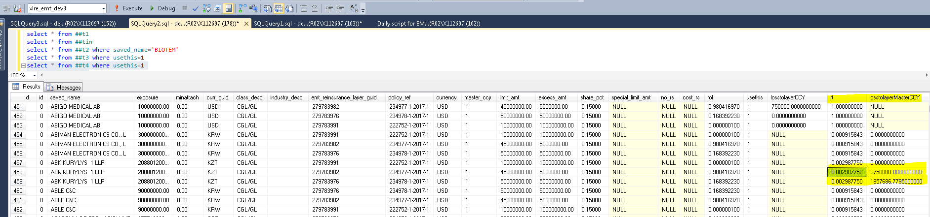
- All the #t4 records are moved to #t5 with 2 additional colums – rate1 and losstolayerUSDFromMaster. Here rate1 is the exchange rate of insurance currency with respect to ‘USD’.
If Master currency is ‘USD’ as well, for those entries exchange rate would be ‘1’ ie rate1 will be Hence consequently losstolayerUSDFromMaster’ will be same as losstolayerUSDFromCCY. In general ‘loss with respect to USD’ is calculated as below and populated in ‘losstolayerUSDFromMaster’

select ##t4.*,rate as rate1,losstolayerUSDFromMaster=case when losstolayerCCY IS null then losstolayerMasterCCY*rate else null end into ##t5 from ##t4
inner join @treatyRates on ccy=@master_ccy order by saved_name
ie losstolayerMasterCCY is converted to USD

Rate1 is calculated from @treatyRates table variable which is populated based on the below select. This table variable basically contains the exchange rate details of all the currencies available in re-insurance layer with respect to ‘USD’ for the re-insurance programs selected
SELECT DISTINCT coalesce(currency,'USD')curr_guid, MAX(effective_dt) AS effective_dt,
dbo.fn_getXRate(coalesce(currency,'USD'), 'USD', MAX(effective_dt)) AS rate
FROM t_emt_reinsurance_layer l
INNER JOIN t_destiny_xrates x ON x.CCY=coalesce(currency,'USD') COLLATE database_default
WHERE emt_reinsurance_program_guid=203355921 -- Program number
GROUP BY coalesce(currency,'USD')

Here the exchange rate of each currency with respect to USD is available in t_destiny_xrates table. The function fn_getXRate retrieves the latest rate for a from-to currency combination.
For example,
For any from_currency if the to_curr is USD the latest exchange rate matching the from_currency is returned.
For any from_currency if the to_curr <> USD then then the latest exchange rate corresponding to the from_currency is divided by the latest exchange rate of the to_curr and returned

For from_currency =’GBP’ and to_curr=’USD’ the returned value would be ‘1.331500000’.
When this value is multiplied with losstolayerCCY of 25000.05000 , we get the value 332875.06658 as below
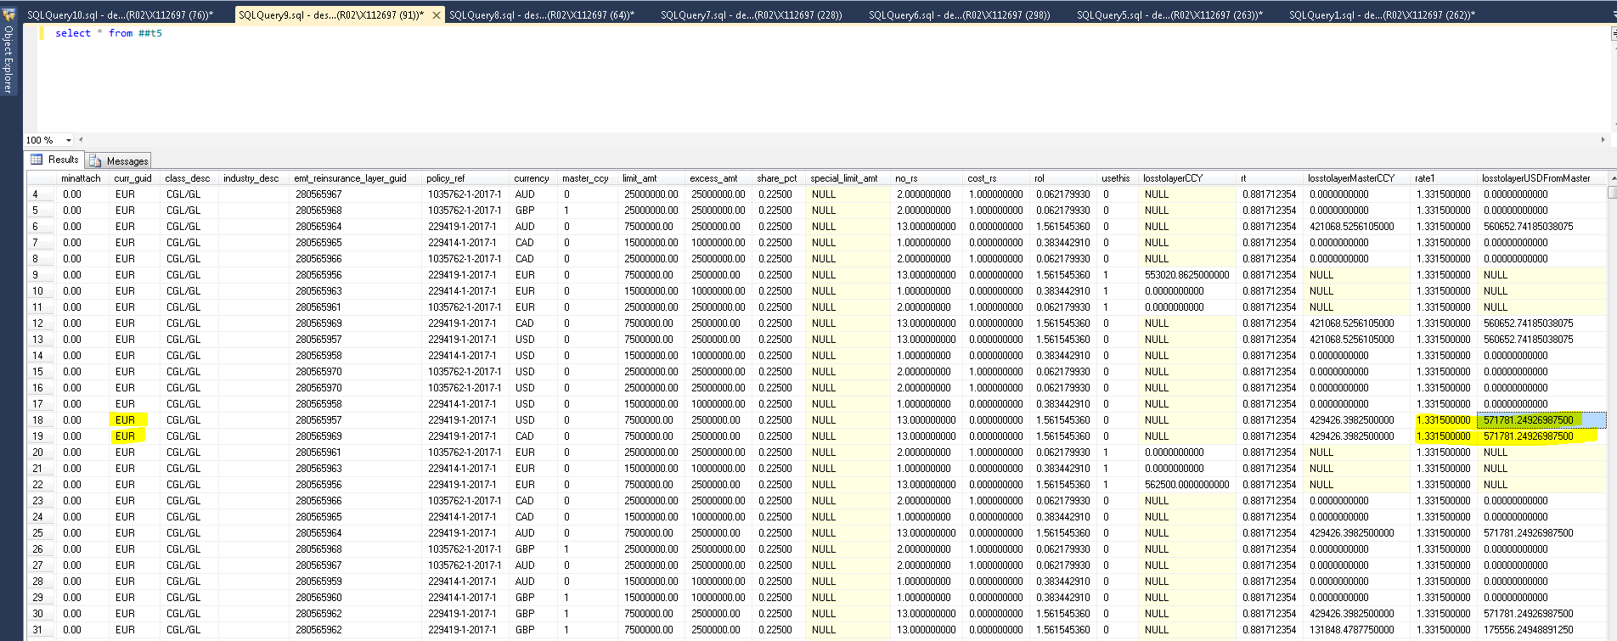

- Now ‘losstolayerCCY’ is converted to USD in #t6. First the exchange rate of the corresponding insurance currency with respect to USD is calculated in ‘rate2’ and ‘losstolayerUSDFromCCY’ is calculated as below. Also ‘Caploss’ is calculated from ‘losstolayerCCY’ by multiplying with the exchange rate with respect to USD
select ##t5.*,rate as rate2,losstolayerUSDFromCCY=case when losstolayerCCY IS not null then losstolayerCCY*rate else null end ,
cap_loss=case when losstolayerCCY IS not null then losstolayerCCY*rate else null end
into ##t6 from ##t5
inner join @treatyRates on ccy=currency order by saved_name

Rate2 is calculated from @treatyRates table variable which is populated based on the below select .
This table variable basically contains the exchange rate details of all the currencies available in re-insurance layer with respect to ‘USD’ for the re-insurance programs selected

SELECT DISTINCT coalesce(currency,'USD')curr_guid, MAX(effective_dt) AS effective_dt,
dbo.fn_getXRate(coalesce(currency,'USD'), 'USD', MAX(effective_dt)) AS rate
FROM t_emt_reinsurance_layer l
INNER JOIN t_destiny_xrates x ON x.CCY=coalesce(currency,'USD') COLLATE database_default
WHERE emt_reinsurance_program_guid=203355921 -- Program number
GROUP BY coalesce(currency,'USD')

Here the exchange rate of each currency with respect to USD is available in t_destiny_xrates table. The function fn_getXRate retrieves the latest rate for a from-to currency combination.
For example, for any from_currency if the to_curr is USD the latest exchange rate matching the from_currency is returned.
For any from_currency if the to_curr <> USD then then the latest exchange rate corresponding to the from_currency is divided by the latest exchange rate of the to_curr and returned

For from_currency =’GBP’ and to_curr=’USD’ the returned value would be ‘1.331500000’.
When this value is multiplied with losstolayerCCY of 25000.05000 , we get the value 332875.06658 as below

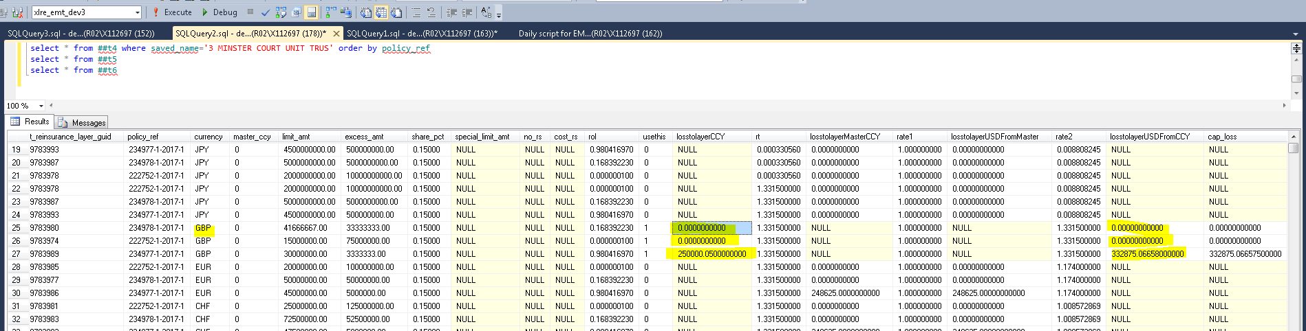

- Next all the existing entries corresponding to the ‘re-insurance program’ considered in this loss calculation are deleted from ‘t_emt_results’ table. If only specific classes were selected for the loss calculation only those entries are deleted and the others remain as such. When no class is selected, all the entries of that re-insurance program are deleted
select distinct policy_ref,limit_amt*share_pct*rate caploss,@master_ccy ccy,limit_amt,share_pct,rate
into ##caploss from ##t5
inner join @treatyRates on ccy=@master_ccy
where master_ccy=1

- The cap limit for each policy level that can be payed by XL is calculated into a separate temp table #caploss per policy basis on the master currency as per the below logic
select distinct policy_ref,limit_amt*share_pct*rate caploss,@master_ccy ccy,limit_amt,share_pct,rate
into ##caploss from ##t5
inner join @treatyRates on ccy=@master_ccy
where master_ccy=1
- If ‘losstolayerUSDFromCCY’ value in #t6 is within the caploss limit for that policy in #caploss, it is retained. If it is greater than the caploss amount then caploss amount is updated as ‘losstolayerUSDFromCCY’ in #t6
- The entries from #t6 whose ‘usethis’ column value is 1 alone are inserted into t_emt_results. During this insertion, lossUSD is calculated based on the below logic
lossUSD=case when losstolayerCCY IS null then losstolayerUSDFromMaster else losstolayerUSDFromCCY end ,

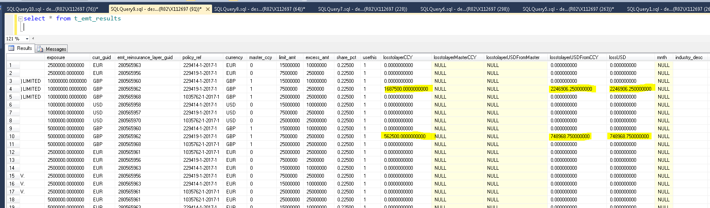

- The ‘lossusd’ thus calculated is populated in ‘exposure_count_amt’ column of insurance table for that particular program. If class is also specified, the value is updated for the insurance entries corresponding to that particular class under that program.
- This lossUSD is the loss amount that is summed up to get the total exposure, which XL will be providing in case of any loss to the client.
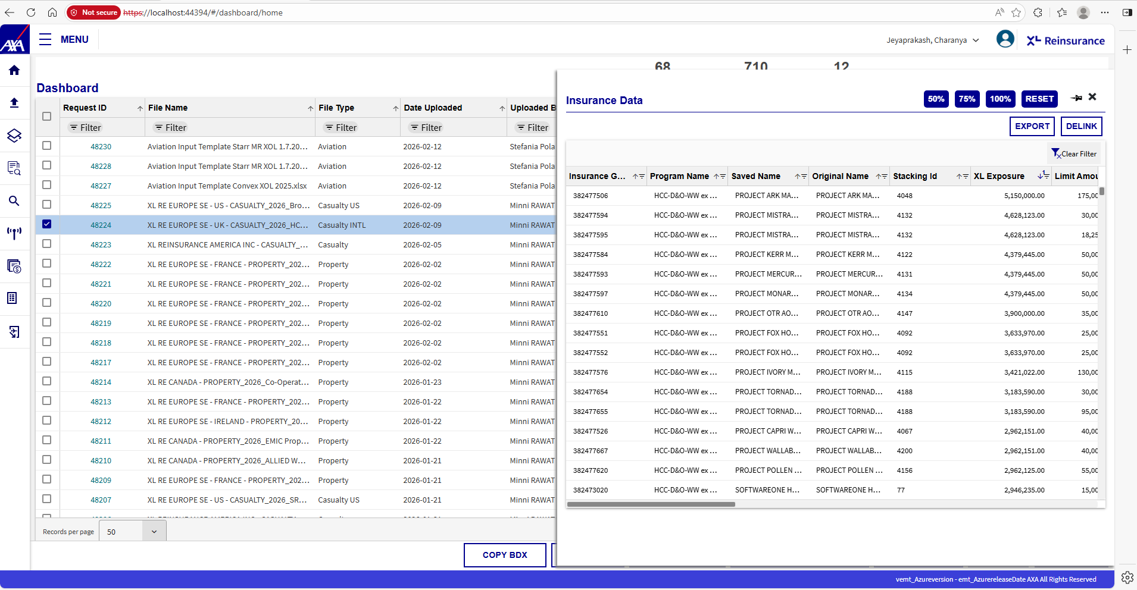

RDS from EMT Application UI
In order to simulate an RDS from EMT application, first the user needs to
- Open XPO application

- Navigate to the RDS screen. Either import for a new RDS file or select an existing scenario by using the Load Scenario option. For new RDS import choose the re-insurance program for which loss scenario is to be calculated from the left pane. By default, all the LOB/class in the right pane will be checked. For existing RDS these values will be auto populated once the scenario is chosen.
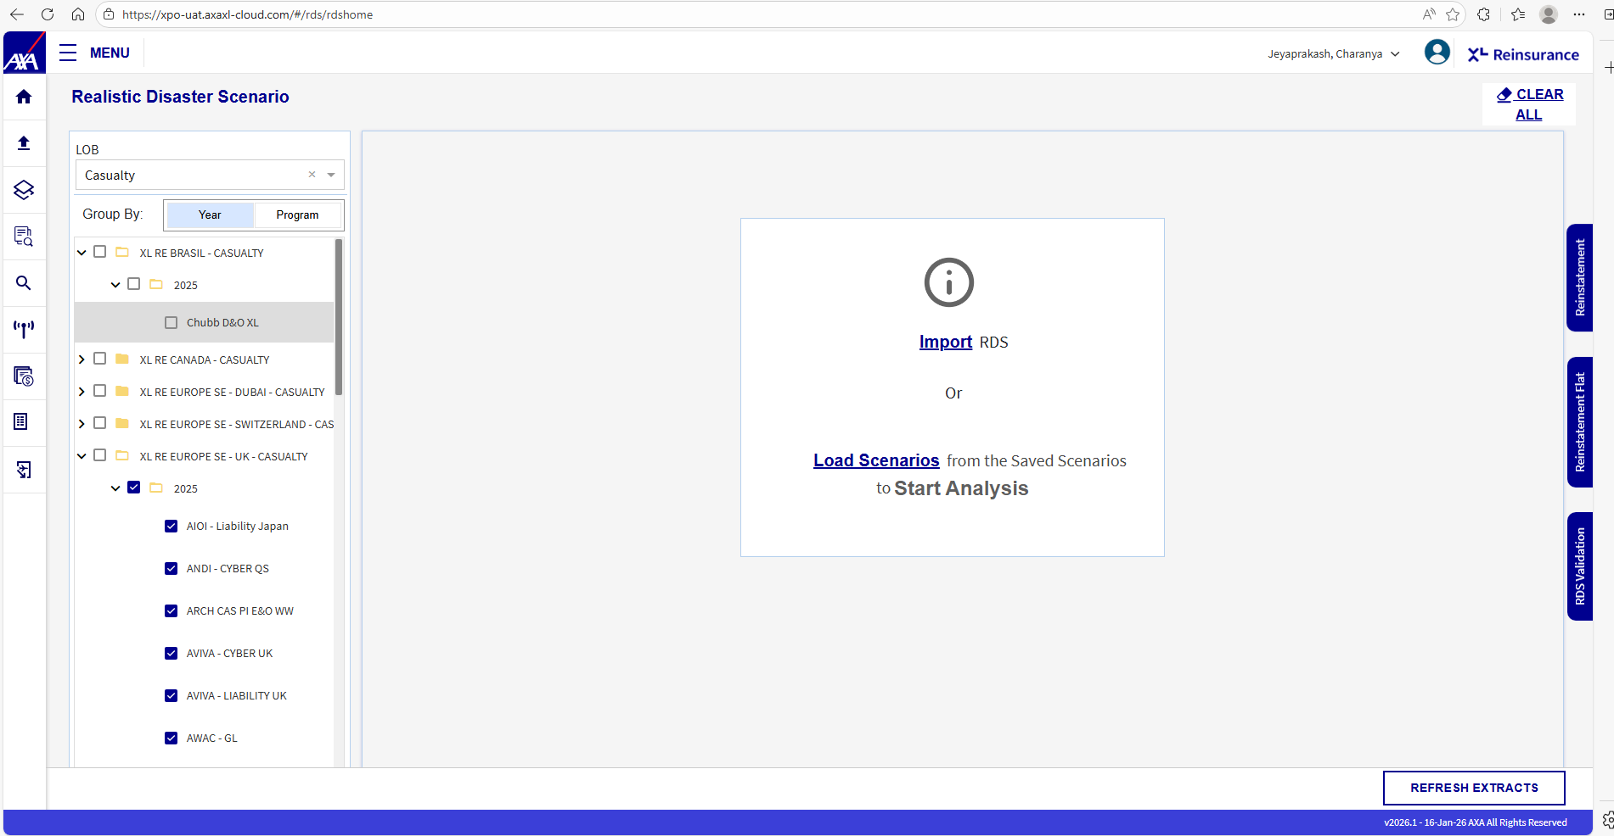
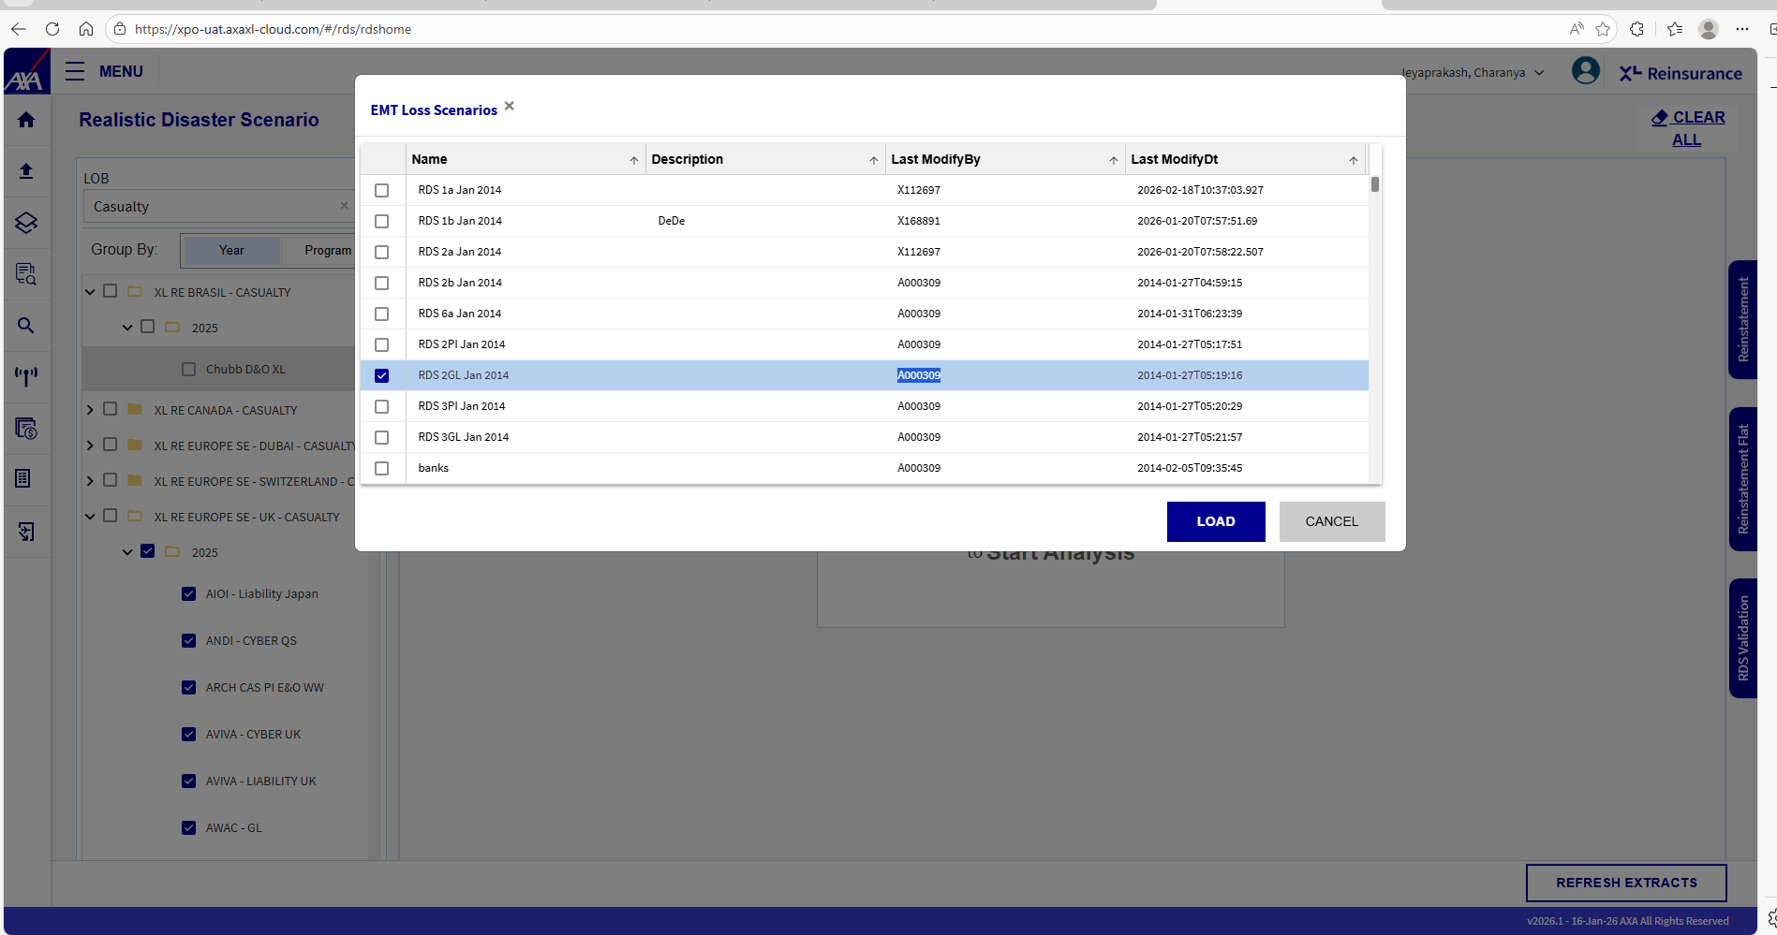

- Select the various parameters for New Scenario as below:
- Programs Involved
- Companies/Policy holders (Usually the high risk companies with huge loss exposure)
- LOB/Class
- Scenario name – Custom name chosen by the user
- Date of Loss (DOL) – optional (Only if the check box next to this is selected, this value will get saved along with the scenario details

- Once the parameters are chosen, the scenario has to be given an appropriate name and saved using the ‘Save’ button in the menu.

- Let us consider a sample scenario named ‘TestScenario1’ with the below parameters:
- On the left pane, the OBUs will be listed out. Under each OBU the reinsurance programs will be listed in two ways – 1. Program wise or 2. Year wise
- Select the respective program from the OBUs listed on the left pane of the ‘Loss Scenario window, eg: OBU –XL RE EUROPE SE – UK – CASUALTY

- Under this OBU choose any of the Programs : AMLIN – MAIN PROG , ARCH PI/D&O/GL

- Then choose the Class – CG/GL required.

- Choose the ‘Date of Loss’ DOL – 7/19/2017. DOL is not mandatory, if the user wants to calculate the loss based on a specific date, it can be done by choosing the corresponding check box next to DOL on the right pane

Once the scenario is created with all these parameters, it has to be saved.
Thus the scenario gets saved.
->To Load saved scenario
  - Click on the ‘Load Scenarios’ link, a new pop-up window will be open.
  - Select the ‘Scenario’ to be loaded and click on the ‘Load’ button in the pop-up window
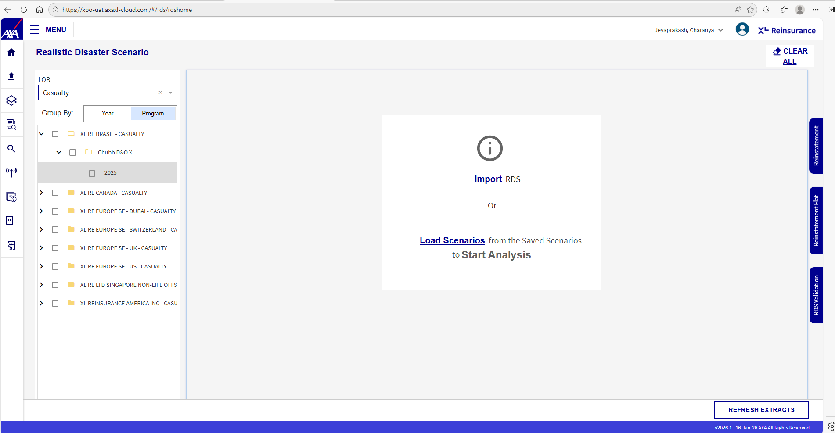
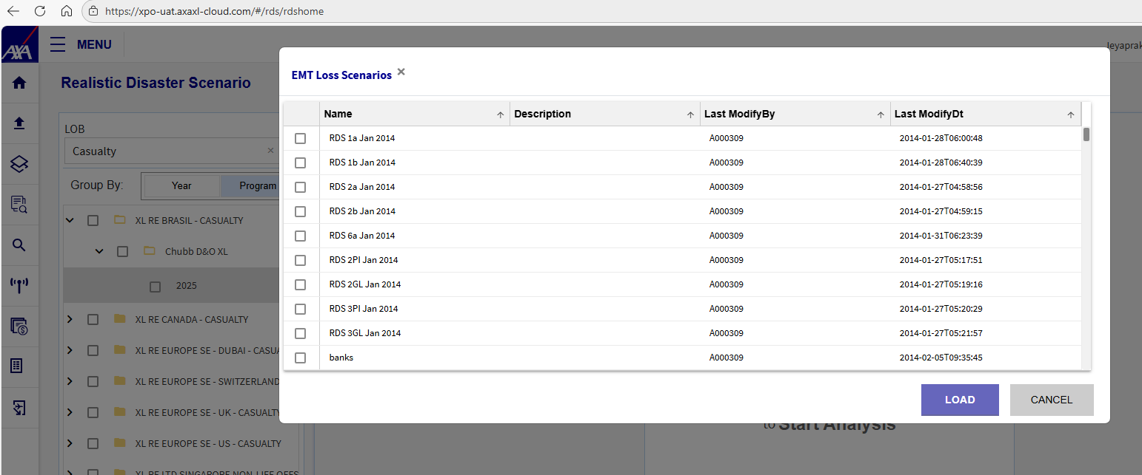
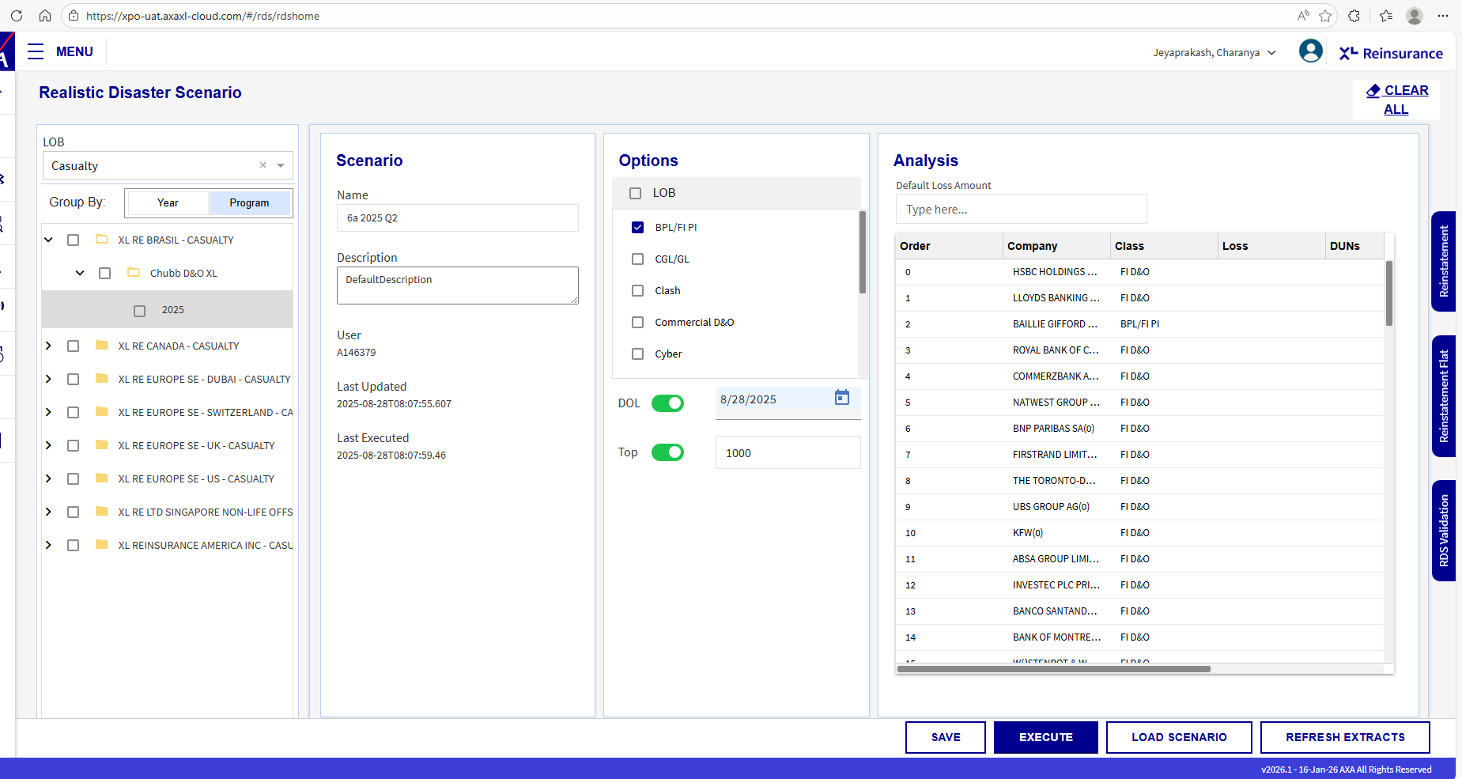
To Delete a saved/existing scenario
  - Click on the ‘Load’ icon at the menu tab, a new pop-up window will be open.
  - Select the ‘Scenario’ to be deleted and click on the ‘Delete’ button in the pop-up window
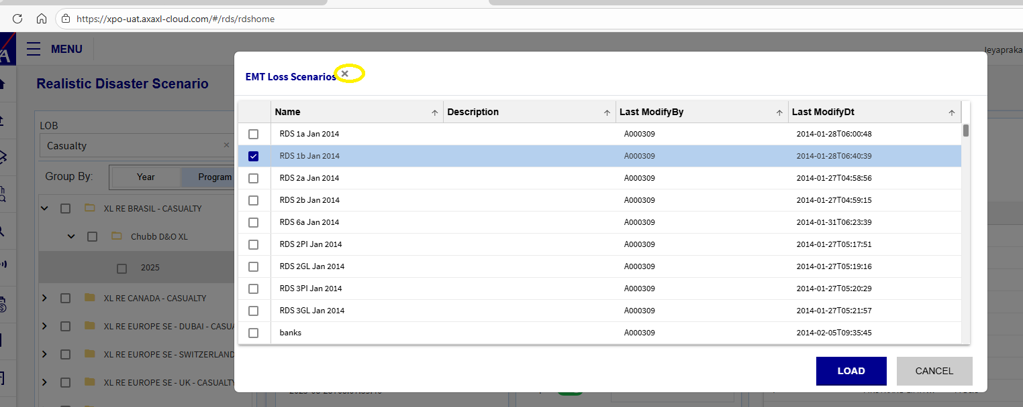
- Another way of dealing with an existing scenario is by importing the scenario details from an excel file saved in specific format using the import button.
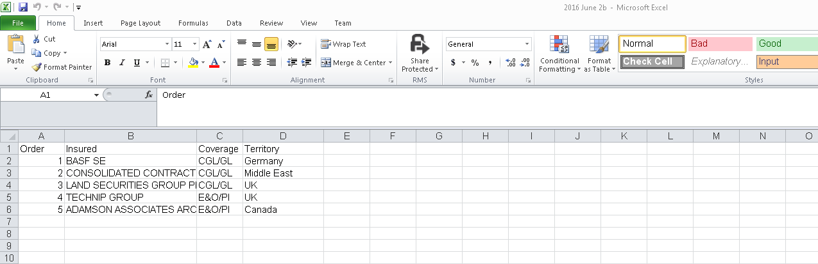

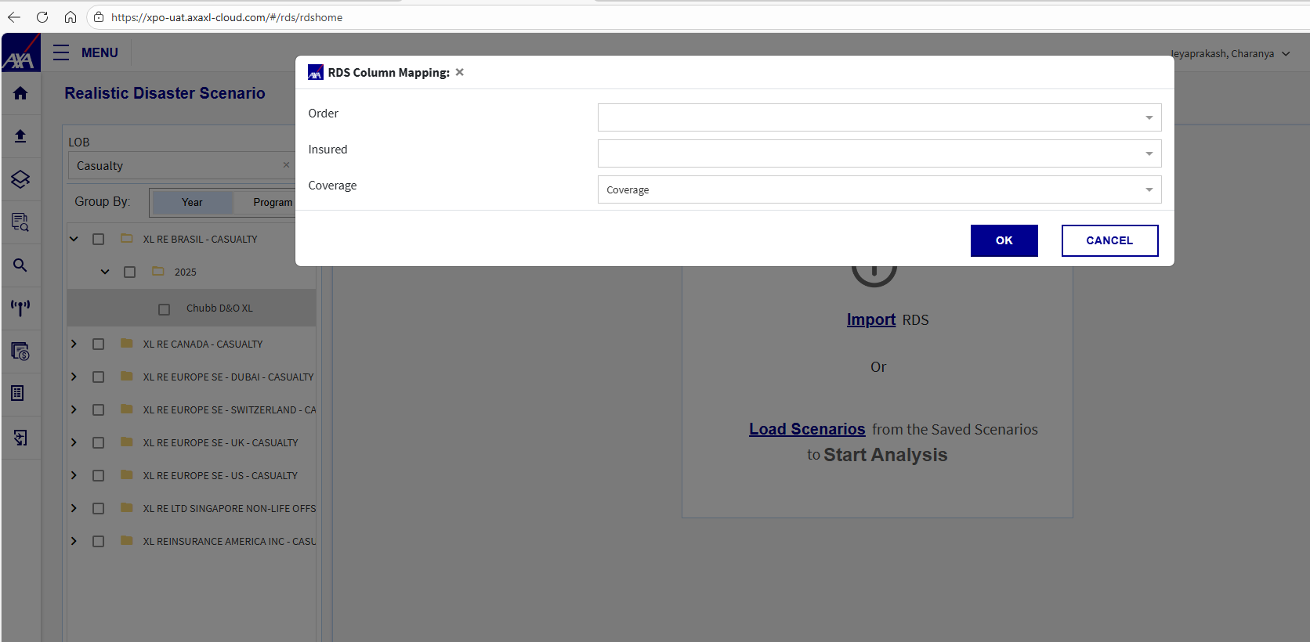

Details on scenario saving at backend and database calculations involved in report generation
- When the ‘Save’ button is clicked the primary details such as ScenarioID(PK generated),Name and Description are saved into t_emt_loss_scenario_group table

- The other details involving program, company, class etc., are stored in t_emt_loss_scenario table

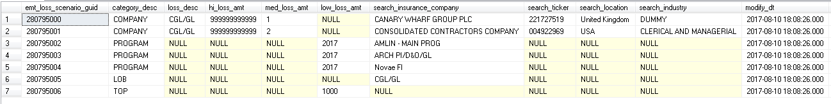

- Once the scenario gets saved, when the ‘Execute’ button is clicked the ‘RDS report’ gets generated in the bottom window.
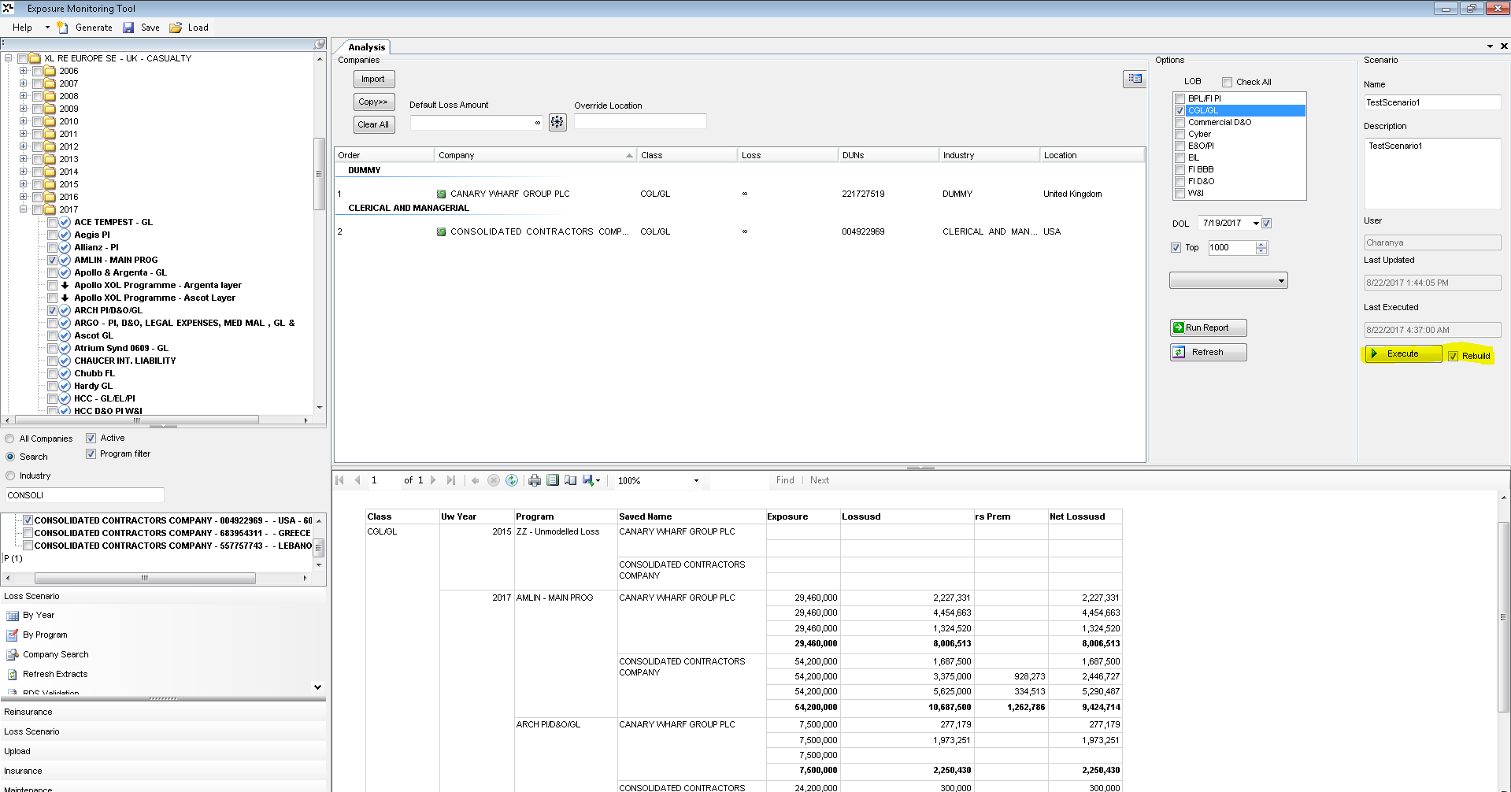

- First it is checked whether the scenario is saved or not. Only when the scenario details are available in the backend tables, the process proceeds else no results are generated.
For a saved scenario, if it has already been executed once then
  - The RDS report is just re-generated, the previously generated results from t_emt_results are loaded again in the window without recalculation only when “Rebuild” check box is ‘checked’
  - In case the “Rebuild” check box is checked the results are generated afresh again after recalculation.
- During a first run of the scenario or during a re-run with “Rebuild” option, initially the stored procedure “PrepareLossScenario” is called, where the below steps are executed

  - The column ‘execute_dt’ in the table t_emt_loss_scenario_group is updated with current date for the particular scenario.
  - If the scenario includes ‘company’ as well as ‘program’ then the ‘Scenario ID’ and ‘Reinsurance program ID’ concerned are selected after checking for existence of active reinsurance contract.
  - In case the scenario includes only ‘Company/Companies’ , the ‘Scenario ID’ and ‘Reinsurance program ID’ whichever includes that particular company/companies in its insurance data with an active contract is selected

- Next the stored procedure process_results is executed where the lossUSD calculation happens as explained in the lossUSD logic explained previously and the results are loaded into t_emt_results table 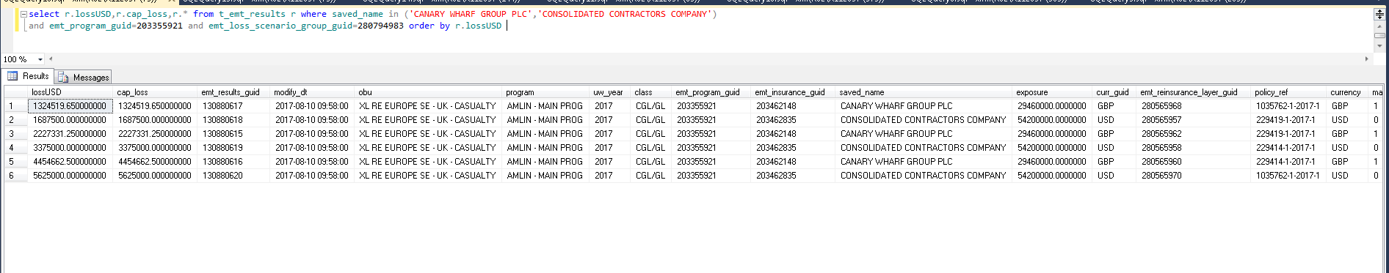

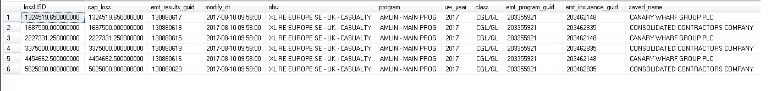

- Next the SP postscenario is called where the core logic for RDS is available. It works on the data in t_emt_results as explained in the following steps

- This SP is executed for each ‘Program number’, ‘Scenario ID’ combination once.
e.g exec postscenario 281005183,281005180

This SP has 2 parts. One is the CAPLOSS calculation and other is the calculation of ‘RSPREM’ and ‘NETLOSSUSD’
At the end these calculated values are updated in the respective columns of t_emt_results table for the particular program, scenario combination

1.CAPLOSS Calculation

First the lossUSD(am), saved_name, count, policy_ref and class columns of the entries corresponding to the above ‘Program number’ and ‘Scenario ID’ are sorted based on lossUSD in DESC order and inserted into #tcum table

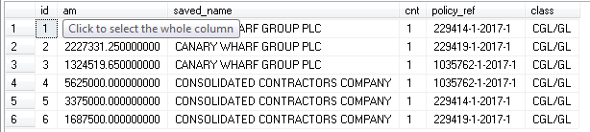

Cumulative sum of lossUSD (am) is calculated row by row into a new column (cumulative_sum) in #tcum2 table

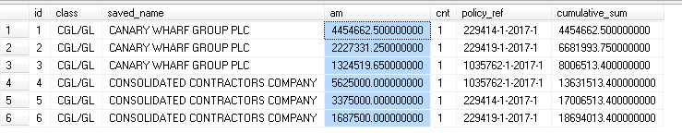

1-> 4454662.50
2-> 4454662.50 + 2227331.25 = 6681993.75
3-> 6681993.75 + 1324519.65 = 8006513.40 etc.,

The final value 18694013.40 is the total estimated loss for the program AMLIN - MAIN PROG in this scenario (which includes only 2 companies – CANARY WHARF GROUP PLC and CONSOLIDATED CONTRACTORS COMPANY)

Policy_ref, limit amount, Sharepct, ROL (rate of loss) and Currency details are pulled for that particular reinsurance program from reinsurance layer information corresponding to the master currency contract details, into #masterpols table

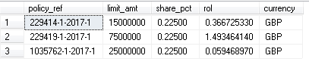
Loss = Sum(lossUSD) at policy_ref level is calculated.
Eg: For policy_ref 1035762-1-2017-1 => 1324519.650000000 + 5625000.000000000 = 6949519.65

Lim = Limit amount at policy ref level is calculated as (limit amount*share percent* min(rate)) from ##masterpols where rate is from v_latestrates for that particular currency
Eg: For policy_ref 1035762-1-2017-1 => (25000000 * 0.22500 * 1.319900000 (for GBP)) = 7424437.50

Besides this, the total number of reinstatements for each policy_ref is pulled from t_reinflat table
All the above calculated column values are inserted into #rspr1

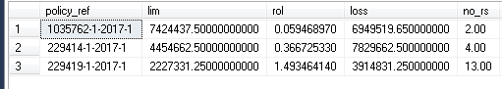

Now the overall loss limit for program AMLIN - MAIN PROG in this scenario (which includes only 2 companies) is calculated as total sum of ‘lim’ multiplied by the number of reinstatements plus 1 default claim from #rspr1 and inserted into #tcum3 table along with columns from #tcum2

Total lim = (7424437.5* (2 +1)) + (4454662.5 * (4+1)) + (2227331.25 * (13 + 1)) = 75729262
Note: Reinstatement will be discussed in detail in the following section

The caploss column ‘cap’ is calculated as per the below logic for each company-contract(policy_ref) level

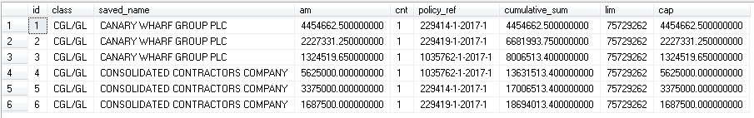

XL can pay maximum of 75729262 to this program for this scenario, so whenever the cumulative_sum (the total loss expected) falls within this limit amount, the lossUSD(am column value) is payable bye XL to that particular company as part of that particular contract(policy_ref) and hence the same is populated in ‘cap’ column

CAP limit is the cut-off or threshold amount that XL can pay for the concerned program for the current scenario

This implies that the lossUSD amount will be borne by XL unless the cumulative sum calculated row by row falls within the limit amount at each level.

E.g If there are 3 entries in the above table each with a lossUSD(am) as 2 lacs, then the cumulative_sum at each level will be 2,4 and 6 lacs respectively

If the limit amount (lim) is 5 lacs, then first and second lossUSD will be payed out and the same will be entered into ‘cap’ column.
When the 3rd row is processed, the remaining limit would be (5-4=1) as 4 lacs has been already been payed out for the first 2 entries.

Now the cumulative_sum would be 6 lacs and available limit would be 1 lac. When (limit amount < cumulative sum) then MAX(lossUSD+(limit amount – cumulative_sum),0) would be calculated.

Which is MAX(2+(5-6),0) = 1, so this remaining 1 lac alone will be calculated as ‘cap’ for the 3rd entry with lossUSD 2 lacs. Since only 1 lac is remaining of the total limit amount that alone is payed out as the other 1 lac lossUSD cannot be covered due to limit amount exhaustion.

This ‘cap’ column value is updated in ‘cap_loss’ column of t_emt_results table

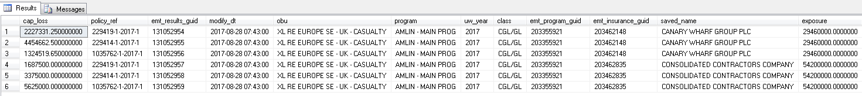

Re-instatement Premium (rsprem) and NetlossUSD

Re-instatement premium is the ‘Premium Amount’ to be paid by the insurance company to XL when they purchase a ‘Reinstatement’ for a particular contract.

When there is a ‘Reinstatement Premium’ factor, that amount need to be subtracted from ‘caploss’ to arrive at ‘NetlossUSD’ which is the final amount to be paid as claim by the reinsurer(XLC)

Here, the steps involved in calculating ‘Re-instatement Premium’ and ‘NetlossUSD’ are discussed.

Initially ‘rsprem’ column in t_emt_results is updated as ‘0’ for the ‘scenario_id’,’program_number’ combination.

##tcumM

LossUSD is summed up at each policy_ref and saved name/company name level and the below values are retrieved

Row ID – partitioned by policy_ref and ordered based on ‘excess amount’, its count,
Limit - Limit amount * share percent
Rol – rate of loss
Currency

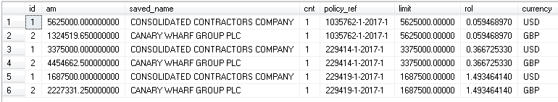

t_emt_results

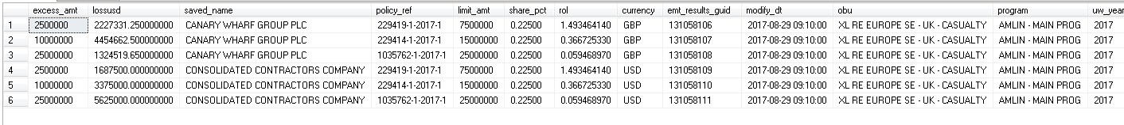

All the values from #tcumM along with the exchange rate for the respective currencies are pulled from the view ‘v_LatestRates into #tcumM1

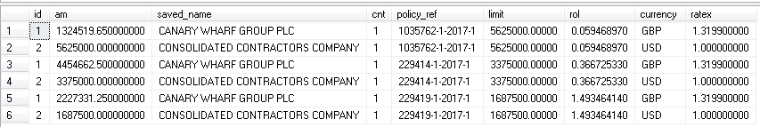

The columns from #tcumM1 are pulled into #tcumM2 along with a new column ‘Cumlative_sum’ in which the cumulative sum is calculated after ordering by policy_ref and ID

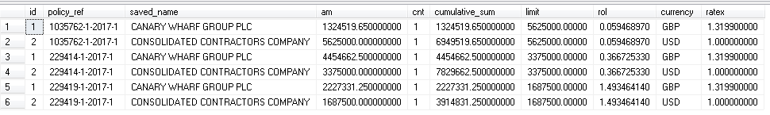
Eg: For policy 1035762-1-2017-1
1324519.65
1324519.65 + 5625000 (next row’s lossUSD) = 6949519.65 etc.,

Now the entries in #tcumM2 are consolidated on policy_ref basis and layernum is given according to the order of excess amount.

Limit is calculated as (limit_amt*share_pct from layer information)
Layer data of the corresponding reinsurance program is joined with t_emt_layer_lob table (inturn pulled from lookup. Here it is for ‘CGL/GL’)

These values are populated in #rsprM1

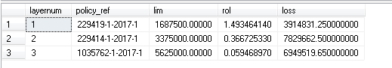

Reinstatement

It is an add-on cover purchased by the insurance company from XL on top of the base policy, to cover any additional loss encountered during the policy cycle.

By default, XL pays for 1 claim during the policy cycle. If the insurance company/cedant expects more than 1 loss during the policy cycle, it purchases additional reinstatements.

The ‘t_reinst’ table has one or more reinstatement entries for a particular policy which has 2 main columns – how_many and as_to_prem_pct

How_many – indicates the number of claims that can be made after the default claim
As_to_prem_pct – the premium percent to be paid by the Cedant while making that particular claim

For example for the below mentioned policy there are 3 reinstatement entries ordered by reinst_guid. The order represents the order of purchase of the reinstatement and hence determines which reinstatement is to be applied first and the consecutive sequence.

As per the below example,
- for the first claim (made after the default claim) under reinst_guid 201842898 the insurance company/cedant should pay 75% of the premium
- for the 2 consecutive claims (second and third) under reinst_guid 201845096 no premium has to be paid
- For the next (fourth claim) under reinst_guid 232384450 no premium has to be paid as well

Since some reinstatements cover multiple claims as in reinst_guid 201845096, they are split into individual entries and loaded into #trein table

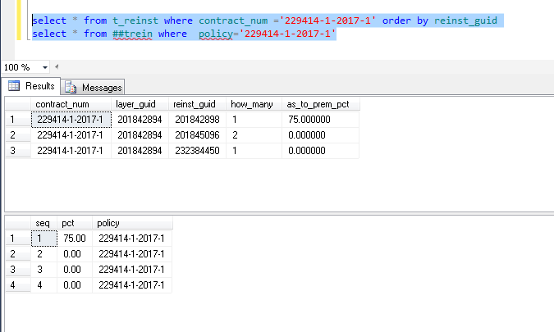

Now the policy number and the number of reinstatements for it are moved into #rspM4
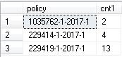

Going back to the policy details in #tcumM2, the reinstatement details from # rspM4 are appended to #tcumM2 details and are populated in #tcumM3 along with 3 new calculated columns – rein, lim, cap
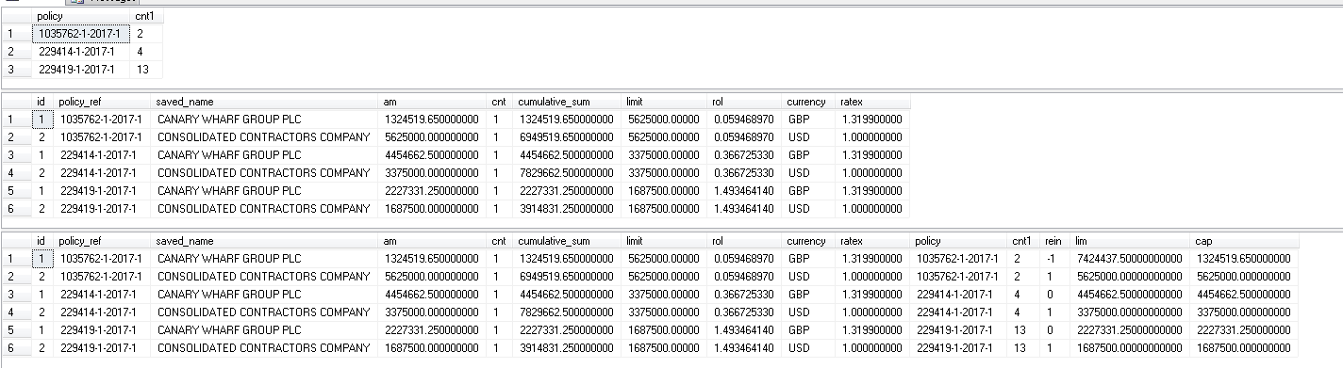

Rein – floor(cumulative_sum/(limit*ratex))-1

For policy 1035762-1-2017-1, ‘CANARY WHARF GROUP PLC’
Floor(1324519.65/(5625000*1.3199)-1 = (-1)

Lim – Total policy level limit (limit column) * Exchange rate

Cap – When limit * ratex * cnt1>cumulative_sum then am (lossUSD)
else dbo.maxi (am+(limit * cnt1-cumulative_sum),0)

Since cnt1 indicates the number of reinstatement, (limit * ratex * cnt1) indicates the total limit for that particular policy X number of claims X exchange rate. If this exceeds the cumulative sum then it means that the available limit is sufficient to pay the lossUSD and hence that value is populated in ‘lim’ column

Otherwise, only the amount which falls within the payable limit for that policy am + (limit*cnt1-cumulative_sum) ie the lossUSD – (total limit of the policy – cumulative_sum) is only payable and hence populated in ‘lim’ column

Rein updates

If any of the calculated ‘rein’ is greater than the original reinstatement count (cnt1) for a particular policy then the minimum ‘rein’ column value of the policy is updated to the original reinstatement count (cnt1)

If any of the calculated ‘rein’ column value is same as the original reinstatement count(cnt1) , for a particular policy then that entry of the policy whose ‘rein’ is greater than the minimum ‘rein’ in the policy group is updated to 0

For the entries whose rein=0 and the lossUSD (am) = lim (limit for that particular policy) then rein is updated as 1

Eg: For policy 1035762-1-2017-1, CONSOLIDATED CONTRACTORS COMPANY lossUSD (am) = lim =5625000

For a particular policy and ‘rein’ value group if there exists more than one entry whose ‘rein’ value is not 0 then for the record with MAX(ID) in that group‘rein’ is updated as 0.

Next all the values of #rspM5 are inserted into #rspM6 along with ‘pct’ (Premium percentage) from #trein table.
One more calculated column is included rsprem = rol * pct/100 * limit * ratex

Rsprem (Premium received from the cedant) = rate of loss * premium percent/100 * limit * currency rate
Rsprem = 0.059468970 * 100.00 /100 * 5625000.00000000000 * 1 = 334512.956250
(For policy 1035762-1-2017-1)

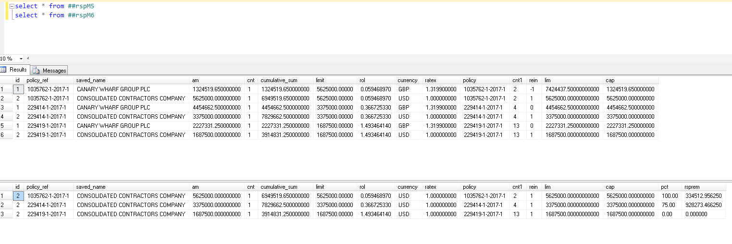

Now based on all the above calculations the end results are updated in t_emt_results

- First the ‘rsprem’ column in t_emt_results is set to ‘0’ for all the entries of the particular program in the specific scenario discussed.

- Then the ‘rsprem’ column is updated with the value of ‘rsprem’ from #rspM6 table

Finally, this premium payed by the cedant is reduced from the ‘caploss’ amount (threshold amount that can be payed by XL as per the cap limit calculated based on various factors above).
Eg: 3375000 – 928273.46625 = 2446726.53375

The final amount thus obtained is updated in ‘netlossusd’ column of t_emt_results for that particular company, policy and scenario combination

